FARMMANAGEMENTSYSTEM

UserStory:
In the Farm Management System (FMS), as a farmer, farm manager, or system administrator, I wanttouseacentralizedSalesforce-basedplatformtorecordandmanage farm, crop, farmer, and buyer information so that all agricultural data is stored securely and systematically. I want to enter and update farm details, crop production records, and buyer transactions easily through a user-friendly interface with proper validationrulesto prevent incorrect entries. I also want the system to generate real-time reports and interactive dashboards so that I can analyze farm productivity, monitor sales, and make informed decisions. Additionally, I want role-based access and secure data storage to ensure that sensitive informationisprotectedwhileenablingsmoothcollaborationamong users. This system will help reduce manual paperwork, minimize errors, improve efficiency, and support data-driven farm management.

INTRODUCTION

ProjectOverview :
The Farm Management System (FMS) is a Salesforce-based application designed to digitize and streamline agricultural operations. It manages data related to farms, crops, farmers, and buyers while providing real-time insights through reports and dashboards. The system helps farmers and managers monitor agricultural activities efficiently and make informed decisions.

Purpose:
Themainpurposeofthisprojectisto:

    - Digitizeagriculturaldatamanagement
    - Improvedataaccuracyandaccessibility
    - Automaterecordhandling
    - Enablereal-timemonitoring
    - Supportdata-drivenfarmingdecisions
    - Enhanceproductivityandtransparency

IDEATIONPHASE

ProblemStatement(CustomerProblemStatementTemplate)

PS | I am (Customer) | I’mtrying to | But | Because | Which makesme feel
PS-1 | Farmer | Maintain farm and croprecords | Dataisoften incomplete or incorrect | Recordsare kept manuallyin registers | Frustrated and confused
PS-2 | FarmManager | Monitor farm productivity and sales | Reports are delayedand inaccurate | Data is scattered acrossfiles and sheets | Stressedand inefficient
PS-3 | Buyer | Accesscrop availability and pricing | Information is not updated regularly | Thereisno centralized digital system | Uncertain and dissatisfied
PS-4 | SystemAdmin | Manageuser access and system security | Unauthorize d access may occur | Access controlis handled manually | Concerned andinsecure
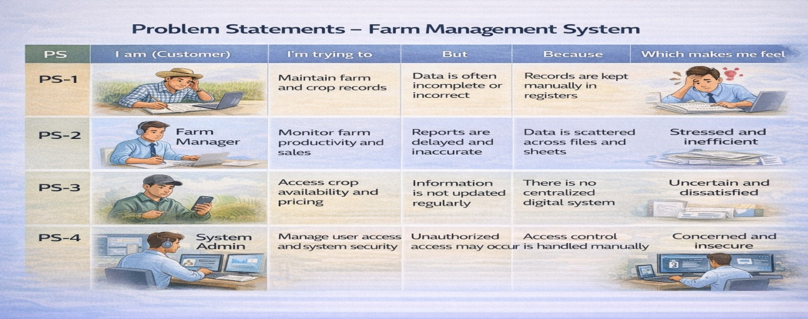

EmpathyMapCanvas
TargetUsers:
    - Farmers
    - FarmManagers
    - Buyers
    - SystemAdministrators
EmpathyAnalysis
    - Think&Feel:Needaccurateandtimelyfarm data
    - Hear:Feedbackfromagriculturalofficers
    - See:Registers,paperfiles,spreadsheets
    - Say&Do:Enterrecordsmanually
    - Pain:Dataloss,errors,delays
    - Gain:Automation,fastreporting
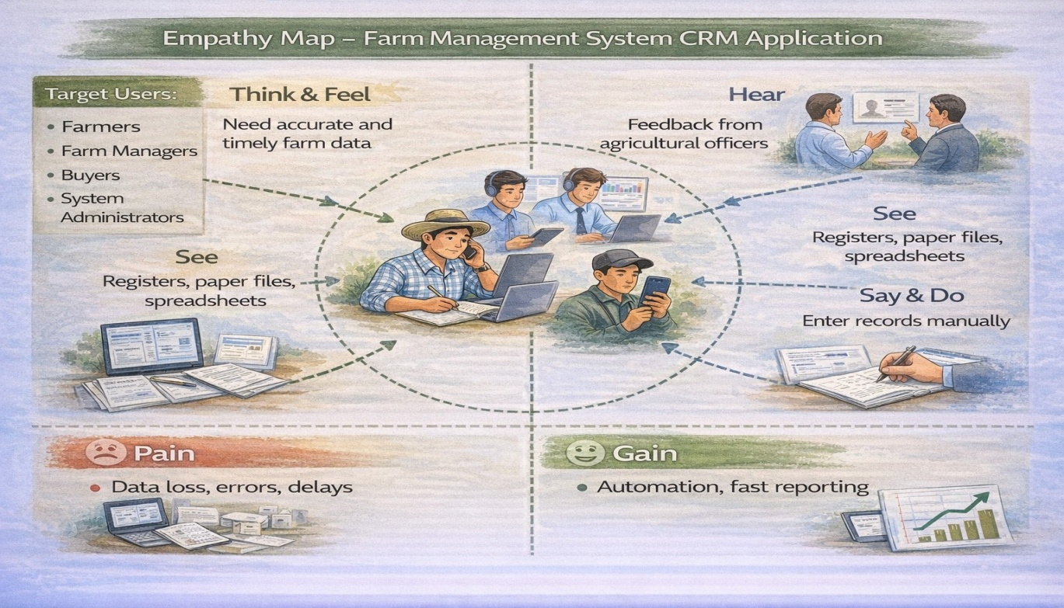

Brainstorming
BrainstormedIdeas
    - Manualfarmrecords
    - Excel-basedmanagement
    - Web-basedsystem
    - Mobilefarm app
    - Salesforce-basedFMS
SelectedIdea
Salesforce-basedFarmManagementSystem.
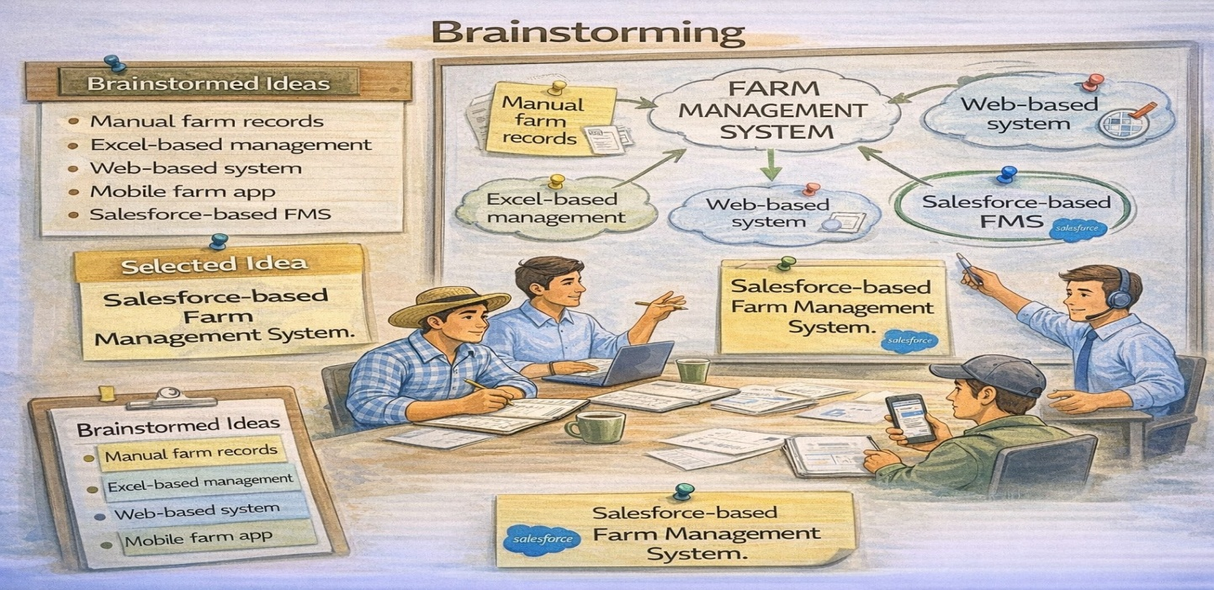

REQUIREMENTANALYSISPHASE

CustomerJourneyMap
Stages:
- Login
- AccessFarmManagementApp
- EnterFarmandCrop Data
- RegisterFarmersandBuyers
- GenerateReports
- AnalyzeResults
- DecisionMaking
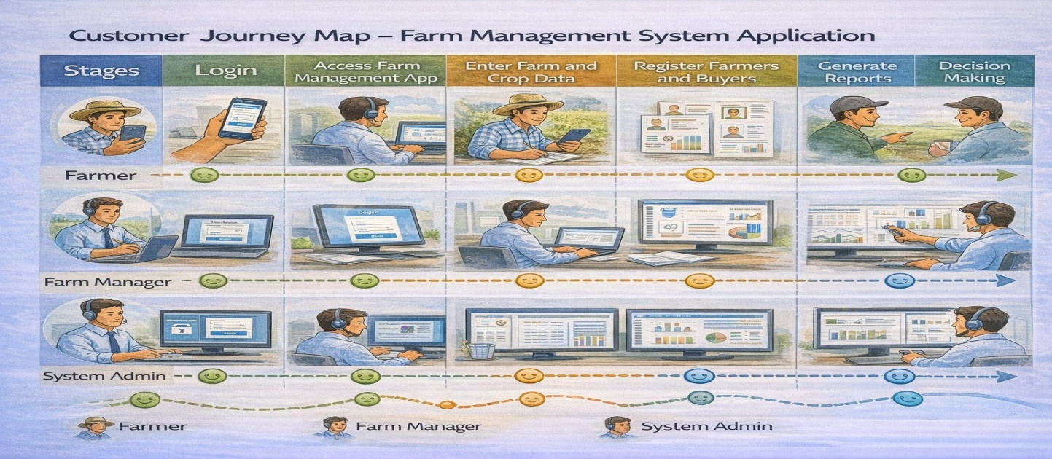

SolutionRequirements
FunctionalRequirements

FRNo | Requirement
FR-1 | UserAuthentication
FR-2 | Farm,Crop,Farmer,BuyerManagement
FR-3 | DataEntryandValidation
FR-4 | RelationshipMapping
FR-5 | ReportGeneration

FR-6 | DashboardVisualization
FR-7 | UserRoleManagement

Non-FunctionalRequirements

NFR | Description | Example
Usability | Easyinterface | SimpleLightningUI
Security | Dataprotection | Profiles&roles
Reliability | Nodataloss | Cloudbackup
Performance | Fastaccess | Reportsin<3sec
Availability | 24/7access | Cloudhosting
Scalability | Handlesgrowth | Morefarms/users

DataFlowDiagram
DataFlow:
User→SalesforceUI→CustomObjects(Farm, Crop, Farmer, Buyer) → Validation Rules → Relationships → Reports → Dashboards
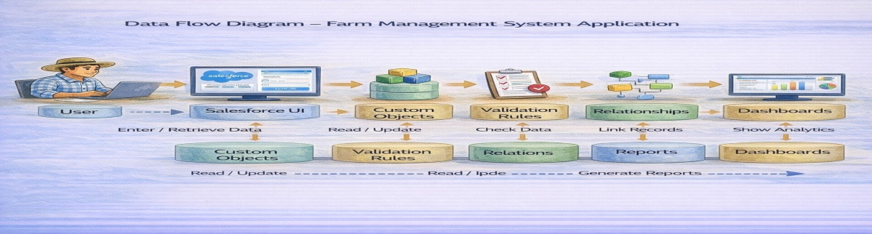

TechnologyStack

Layer | Technology
Frontend | SalesforceLightningUI
Backend | SalesforcePlatform
Database | SalesforceCloud
Automation | ValidationRules
Analytics | Reports&Dashboards

PROJECTDESIGNPHASE

Problem–SolutionFit
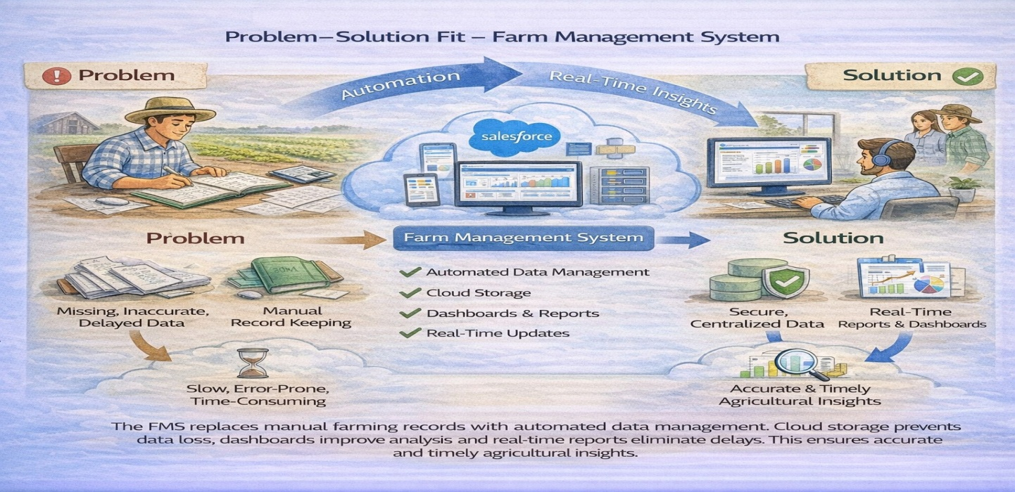
The FMS replaces manual farming records with automated data management. Cloud storage prevents data loss, dashboards improve analysis, and real-time reports eliminate delays. This ensures accurate and timely agricultural insights.

ProposedSolution
FunctionalRequirements

Parameter | Description
Problem | Manualmaintenanceoffarm,crop,farmer,andbuyerrecords leading to errors, data loss, and delays.

Solution | Salesforce-basedFarmManagementSystemwithcentralized data storage and automation.
Innovation | Automateddataentryvalidation,cloudstorage,andreal-time reporting dashboards.
Impact | Improveddataaccuracy,fasterreporting,andbetter decision-making for farmers and managers.es
BusinessModel | Digitalfarmmanagementandagriculturaldataservicesplatform.
Scalability | Supportsmultiplefarms,users,andregionswithcloud-based infrastructure.

SolutionArchitecture
ArchitectureLayers
- PresentationLayer–SalesforceLightningUI
- ApplicationLayer–ValidationRules,Relationships
- DataLayer–CustomObjects
- AnalyticsLayer–ReportsandDashboards

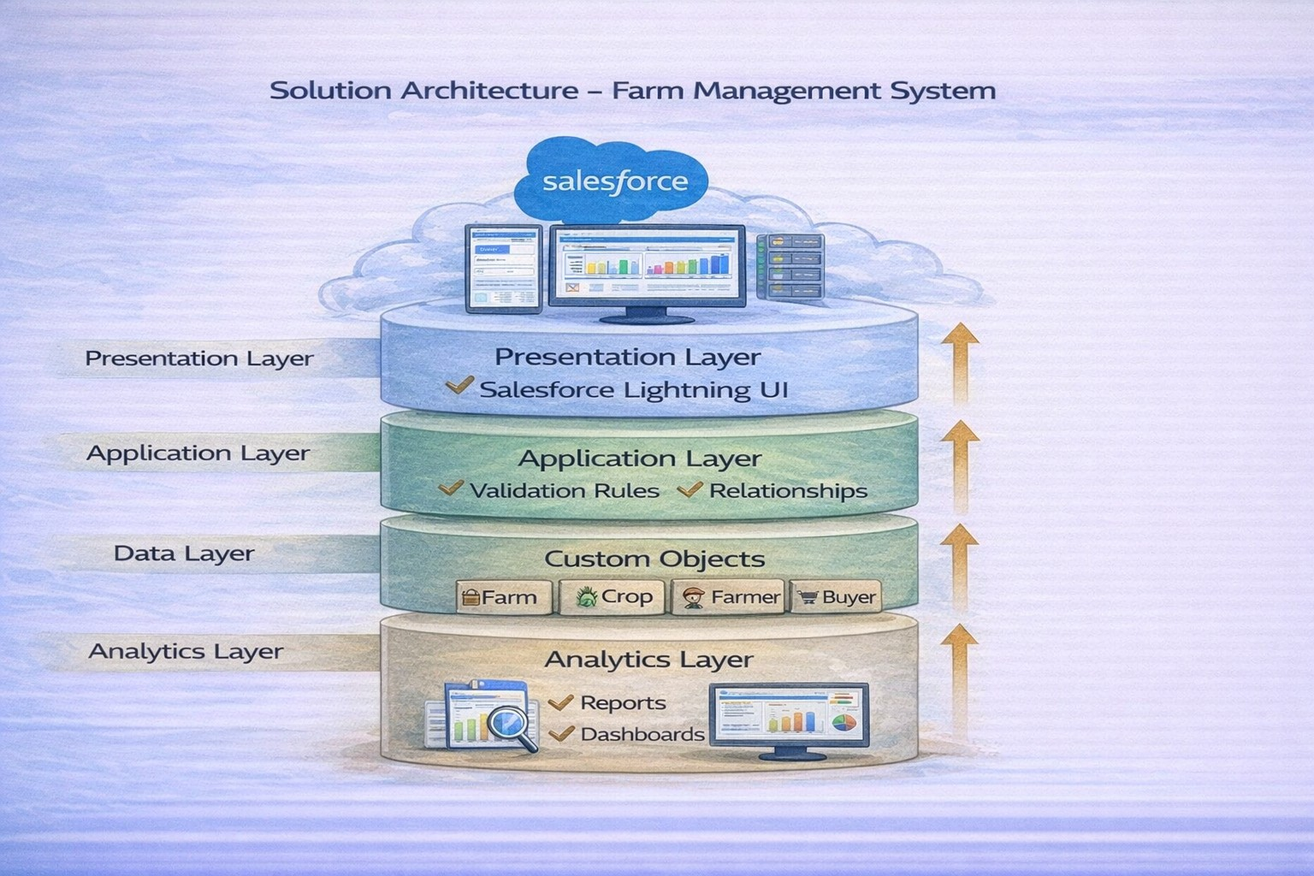

PROJECTPLANNING&SCHEDULING

ProjectPlanning
    - CreatedSalesforceDeveloperOrg
    - Developedcustomobjects
    - ConfiguredtabsandLightningApp
    - Createdfieldsandrelationships
    - Designedprofilesandroles
    - Createdusersandsharingrules
    - Developedreportsanddashboards
    - Conductedtestingandreviews

ProductBacklog,SprintSchedule,andEstimation(4Marks)
Usethebelowtemplatetocreateproductbacklogandsprintschedule

Sprint | Functional Requirement  (Epic) | User Story  Number | UserStory/Task | Story Points | Priority | Team Member  s
Sprint-1 | Developer Setup | USN-1 | Asasystemadministrator,Iwant to create and configure a Salesforcedeveloperaccountso that I can set up and deploy the Farm Management System. | 3 | High | Member1
Sprint-2a | DataModeling | USN-2 | As an admin, I want to create Farm, Crop, Farmer, and Buyer objectswithproperrelationshipsso that agricultural data is stored and  managedefficiently. | 5 | High | Member2
Sprint-2 | DataModeling | USN-3 | Asastaffmember,Iwanttabsand a Lightning App for all farm modules so that I can easily navigate and perform daily operations. | 5 | High | Member3
Sprint-3 | Automation | USN-4 | As a system, I want to validate farm and crop details such as dates, quantities, and mandatory fields so that incorrect or incompleterecordsareprevented. | 3 | High | Member4
Sprint-3 | Automation | USN-5 | Asamanager,Iwantautomated flowsforcropupdatesandbuyer notifications so that farm operations are processed faster without manual intervention. | 3 | High | Member4
Sprint-4 | Security | USN-6 | As an administrator, I want role-basedaccesscontrolfor  farmers,managers,andbuyersso thatsensitivefarmandtransaction data is secure. | 5 | High | Member2
Sprint-5 | Reports | USN-7 | Asafarmmanager,Iwantreports showing crop yield, sales, and buyer transactions so that I can monitor farm performance and  makeinformeddecisions. | 4 | High | Member3
Sprint-6 | Dashboards | USN-8 | As a farm manager, I want dashboards showing crop productivity, sales trends, and operationalstatisticssothatIcan monitor performance visually. | 4 | Medium | Member4

ProjectTracker,Velocity&BurndownChart:(4Marks)

Sprint | TotalStory Points | Duratio n | SprintStart Date | SprintEndDate (Planned) | StoryPoints Completed (as on PlannedEnd  Date) | SprintRelease Date (Actual)
Sprint-1 | 20 | 6Days | 24Oct2022 | 29Oct2022 | 20 | 29Oct2022
Sprint-2 | 20 | 6Days | 31Oct2022 | 05Nov2022
Sprint-3 | 20 | 6Days | 07Nov2022 | 12Nov2022
Sprint-4 | 20 | 6Days | 14Nov2022 | 19Nov2022

ProjectDevelopmentPhase:

ProjectDescription:

TheFarmManagementSystem(FMS)inSalesforceisacomprehensivesolution designedtodigitizeandstreamlineagriculturaloperations.Thisapplicationempowers farmers, farmmanagers, and stakeholders by managing data related to crops, Farm, Farmer, and buyers, while providing actionable insights through reports, and dashboards.

Milestone1-Salesforce:

WhatIsSalesforce?

Salesforceisyourcustomersuccessplatform,designedtohelpyousell,service,market, analyze, and connect with your customers.
Salesforcehaseverythingyouneedtorunyourbusinessfromanywhere.Usingstandard products and features, you can manage relationships with prospects and customers, collaborate and engage with employees and partners, and store your data securely in the cloud.

Activity1:
CreatingaSalesforceDeveloperOrg:

ADeveloperorghasallthefeaturesandlicensesyouneedtogetstartedwithSalesforce.
- SearchDeveloper.salesforce.com/signup
- EnterthefollowingdetailslikeFirstname,lastname,Email,Role,Company, Country/Region, Postal code, and Username must be unique.
- Clicksignmeup,afterafewminyouwillreserveamailsalesforceorgandbyusing the verify account link you can create your new password.
- Clicksave.
- Searchlogin.salesforce.com
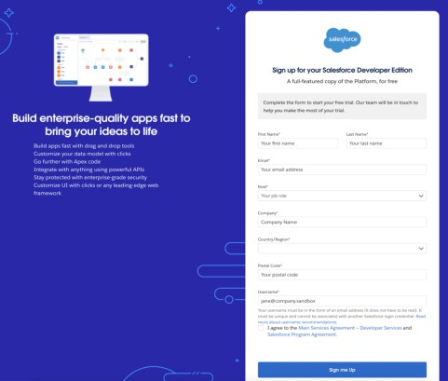

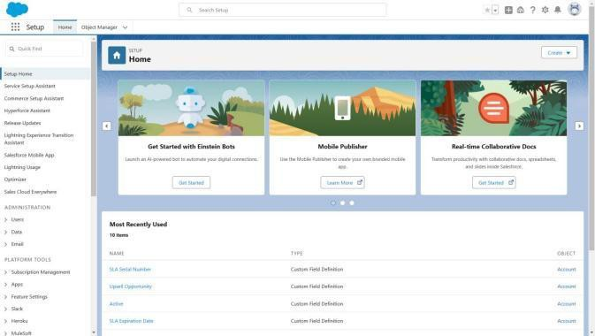
- ByusingusernameandpasswordyoucanintotheSalesforceorg.Thehomepagewill appear below

Milestone2-Object:

Whatisan object?
Salesforceobjectsaredatabasetablesthatpermityoutostoredatathatisspecifictoan organization. It consists of fields (columns) and records (rows).

InThisApplicationWeUse4CustomObjects:
1.Farm 2.Crop 3.Farmer 4.Buyer

Activity1:
CreateacustomobjectforFarm:
Tocreateacustomobject,followthesesteps:
- Fromsetupclickonobjectmanager.
- Clickcreate,selectcustomobject.

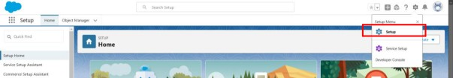

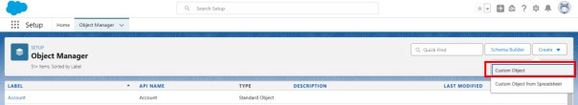

- Fillinthelabelas"Farm".
- Fillintheplurallabelas"Farms".
- Recordname:FarmName"
- Selectthedatatypeas"Text".

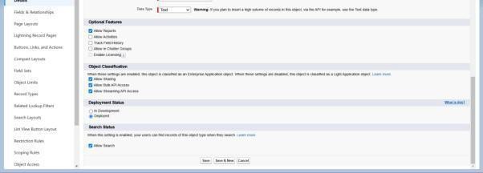

- IntheOptionalFeaturessection,selectAllowReportsandTrackFieldHistory.
- IntheDeploymentStatussection,ensureDeployedisselected.
- IntheSearchStatussection,selectAllowSearch.
- IntheObjectCreationOptionssection,selectAddNotesandAttachmentsrelatedlist to default page layout.

- Leaveeverythingelseasis,andclickSave.

Activity2:

CreationofCropobject:
- ClickonthegeariconandthenselectSetup.
- Clickontheobjectmanagertabjustbesidethehome tab.
- Aftertheabovesteps,havealookontheextremerightyouwillfindaCreate Dropdown click on that and select Custom Object.
  - OntheCustomObjectDefinitionpage,createtheobjectasfollows:
  - Label:Crop
  - PluralLabel:Crops
  - RecordName:CropName

  - Selectthedatatypeas"Text".
  - ChecktheAllowReportscheckboxg.ChecktheAllowSearchcheckbox
h.IntheObjectCreationOptionssection,selectAddNotesandAttachmentsrelatedlist to default page layout i. Click Save.

Activity3:

CreationofFarmerobject:
- ClickonthegeariconandthenselectSetup.
- Clickontheobjectmanagertabjustbesidethehome tab.
- Aftertheabovesteps,havealookontheextremerightyouwillfindaCreate Dropdown click on that and select Custom Object.
  - OntheCustomObjectDefinitionpage,createtheobjectasfollows:
  - Label:Farmer

  - PluralLabel:Farmers
  - RecordName:FarmerName e.Selectthedatatypeas"Text".
f.ChecktheAllowReportscheckbox.g.ChecktheAllowSearchcheckbox.
h.IntheObjectCreationOptionssection,selectAddNotesandAttachmentsrelatedlist to default page layout. i. Click Save.

Activity4:

CreationofBuyerobject:
- ClickonthegeariconandthenselectSetup.
- Clickontheobjectmanagertabjustbesidethehome tab.
- Aftertheabovesteps,havealookontheextremerightyouwillfindaCreate Dropdown click on that and select Custom Object.
  - OntheCustomObjectDefinitionpage,createtheobjectasfollows:
  - Label:Buyer
  - PluralLabel:Buyers
  - RecordName:BuyerName
  - Selectthedatatypeas"Text".
  - ChecktheAllowReportscheckbox.g.ChecktheAllowSearchcheckbox.
- IntheObjectCreationOptionssection,selectAddNotesandAttachmentsrelatedlist to default page layout.
- ClickSave.

Milestone3- Tab: Tab

TabsinSalesforcehelpusersviewtheinformationataglance.Itdisplaysthedataof objects and other web content in the application.

Activity1:

CreationofFarmtab:

Nowcreateacustom tab.

- ClickontheHometab,enterTabsinQuickFindandselectTabs.

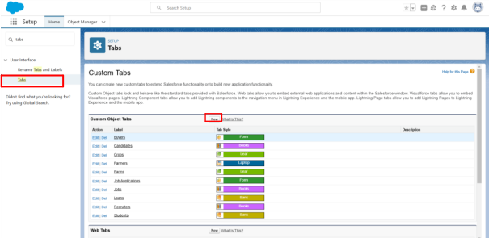

- Undercustomobjecttabs,clickNew.

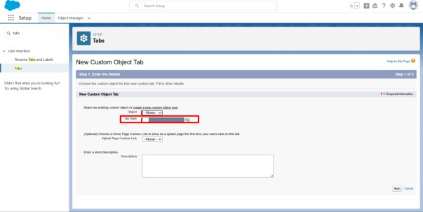

- ForObject,selectFarm.

- ForTabStyle,selectanyicon.
- Leavealldefaultsasis.ClickNext,Next,andSave.

Activity2:

CreationofCroptab:
Nowcreateacustom tab.
- ClickonHometab,enterTabsinQuickFindandselectTabs.
- Undercustomobjecttabs,clickNew.
- ForObject,selectCrop.

- ForTabStyle,selectanyicon.
- Leavealldefaultsasis.ClickNext,Next,andSave.

Activity3:

CreationofFarmertab:

Nowcreateacustom tab.
- ClickontheHometab,enterTabsinQuickFindandselectTabs.
- Undercustomobjecttabs,clickNew.
- ForObject,selectFarmer.
- ForTabStyle,selectanyicon.
- Leavealldefaultsasis.ClickNext,Next,andSave.

Activity4:

CreationofBuyertab:

Nowcreateacustom tab.
- ClickonHometab,enterTabsinQuickFindandselectTabs.
- Undercustomobjecttabs,clickNew.
- ForObject,selectBuyer
- ForTabStyle,selectanyicon.
- Leavealldefaultsasis.ClickNext,Next,andSave.

Milestone4-LightningApp:

WhatisanApp?
Apps in Salesforce area group of tabs that help the application function by working togetherasaunit.Ithasaname,alogo,andaparticularsetoftabs.Thesimplestapp usually has justtwo tabs.

Activity1:
CreatetheFarmManagementSystemapp
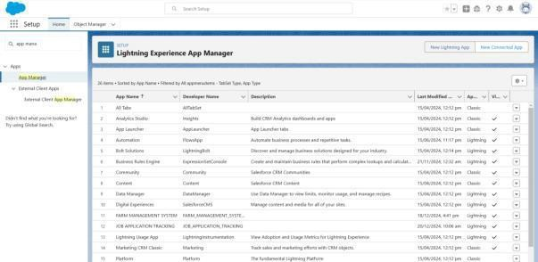

  - FromSetup,enterAppManagerintheQuickFindandselectAppManager.

  - ClickNewLightningApp.FarmManagementSystemastheAppName,thenclick Next
  - UnderAppOptions,leavethedefaultselectionsandclickNext.
  - UnderUtilityItems,leaveasisandclickNext.
  - FromAvailableItems,selectFarm,Crop,Farmer,Buyer
Reports,andDashboardsandmovethemtoSelectedItems.ClickNext.●FromAvailable Profiles, select System Administrator and move it toSelected Profiles.Click Save &Finish.
  - Toverifyyourchanges,clicktheAppLauncher,typeFarmManagementSystemand select the Job Application app.
Note:
- AppLauncher-Displaysavailableapps.
- AppName-Displaysthecurrentselectedapp.
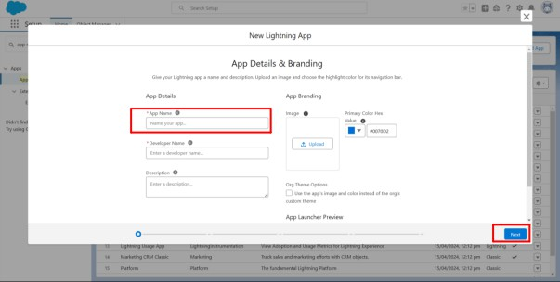

- Navigationmenu-Displaysthetabsavailableinsidetheapp.

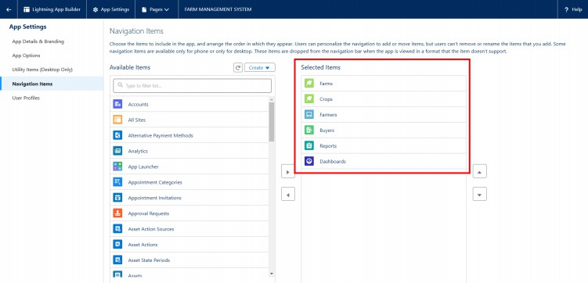

Milestone5-
FieldsandRelationship:Whatarefields?

FieldsinSalesforcerepresentwhatthecolumnsrepresentinrelationaldatabases.Itcan store data values which are required for a particular object in a record.

Activity1:
CreationoffieldsfortheFarmobjects:
- clickthegeariconandselectSetup.ThislaunchesSetupinanew tab.
- ClicktheObjectManagertabnexttoHome.
- SelectFarm.
- SelectFields&Relationshipsfromtheleftnavigation,andclick New

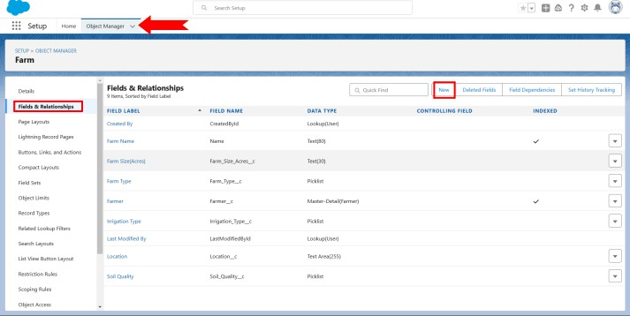

- ChooseDatatypeasapicklist,Clicknext

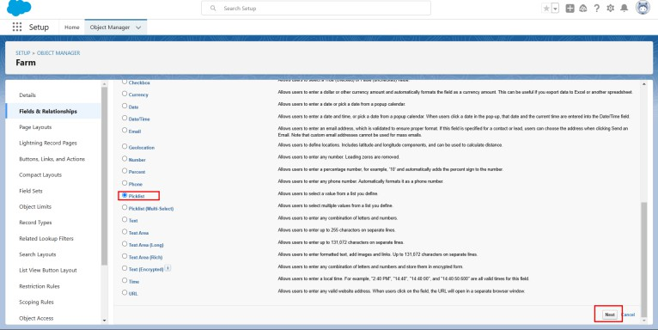

- EnterFieldLabel(FarmType),andEnterValuesas(Crop,Livestock,Mixed) 7.Next,Next Click Save.
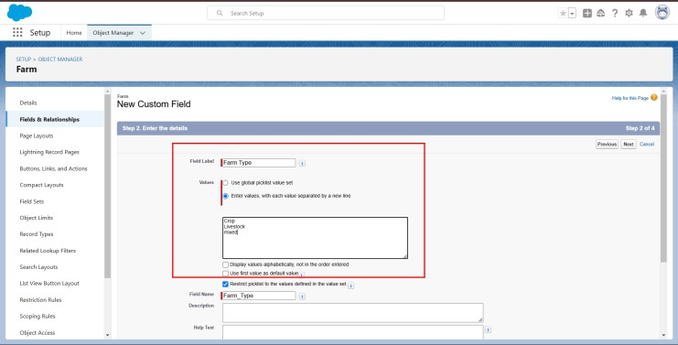

Nowlet'screatetheotherfieldsfollowingActivity1steps1to4andwemustchoosethe data types of the fields carefully.

- NextweCreateanotherPicklistField,Enterfieldlabel(SoilQuality)entervalues (Organic,Cover Crops,Composting)
- AgainweCreatePicklistfield,FieldLabel(Irrigationtype),EnterValues(Sprinkler irrigation,Drip irrigation,localized irrigation)
- Choosedatatypeasatext,enterfieldlabel(Location)4.Choosedatatypeastext,enter field label (size)
5.CreateaMasterDetailrelationShipwithFarmerObject.

Activity2:
CreationoffieldsfortheCropobjects:

1.ChooseDatatypeAsatext,EnterFieldLabelname(CropName),Nextsave.2.Select Data type as date ,Enter Field label (Planting Date),then save .
- Againweselectdatatypeasadate,Enterfieldlabe(Harvestdate),save
- NextWeCreateLookuprelationshiponcropobjectrealtedtoFarmObject.
- Weselectadatatypeascurrency,EnterfieldLabel(ActualYield),NextSaveit.
- SelectDatatypeasaNumber,enterFieldLabel(TotalAcresHarvested),Enter Maximum Length(20) and save.
- NowWecreateFormulaFieldForThatSelectdataTypeAsaFormula,ClickNext.

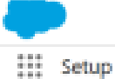
fl�IIR

ClllTlfH:
Ot;eo
LiHYit-,,.S.lllil

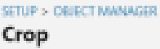
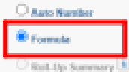
c.,,-...

11Mdl1,II:itwtle.ruhlp■
-..i,...,..,,.
U1i-n"9"--IRa-pw

O...l.Ifi��D

-- l,�ail:INC.....MM!l.....,.,.,...,,:111,., _.i'IMAN.a.,"Sl!lli�-llllillHUaalutln•Hlillila·
:S:l.r,-.,i

I c......,_ �•......,_.Mllla.Hl�ic----lltp:IThlnilllcalllp._,..kl!ti-a1_,.ks;kl-=:l■--IM■F1P111-Th4wDltm,llillll1':Wn'lilh'l'llllllhhllt
O-.-..-,:lllw,a-1111�.......---Nl�lilllhlir""-r)llm_..�('M....,..r-_riu..
......:Lliffb .,..._..,........,,i,1.-.,_......--ia,-- �
._. -..,._.--..u_NiU.JICl.111.:IIUIIWQ'W..,...-,::i
- '!l':lw'mii-;!'M!!l'"""4'�Nlt.,k...-�la�hJiikl�
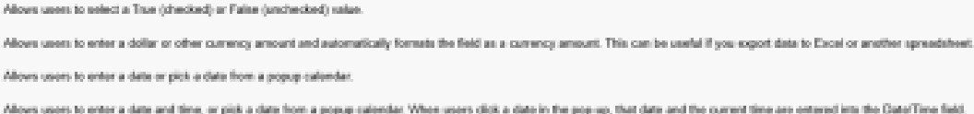T..,�-...................l+t.._...,ii�lt\'IO'M..,.;a,...+11..-•M'lllll'lilht-............:..i...-� ,.
fl.lWnlLC'UNC,Fillir, i::.-i.,..,.�,.._,,....·111o......,_��..1ii....,.,,...........$,,-ill,,,...
-.-c.,....
Ot lllil■
U,CV:
_.,., oc-acr
_........ o-
0
c,,_ M:...._ac- _.._...tdl.-IIN:hlll�.:1-�a.a■..eHlll�hl■-mwa..-._.._..�hd'-..,_�S..•
01.jc,a"'-'.hl &IiiM:otiiltamlfo:- �o:.fll':olt.h!

- EnterFieldLabel(ExpectedYieldperAcre),Selectformulareturntypeas Currency,click Next.
- EnteraFormulaActualYieldDivideByTotalAcreHarvested,thenclicknextand save.

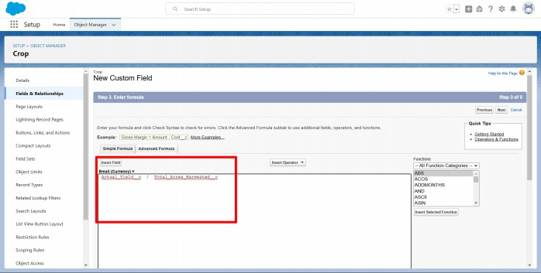

Activity3:
CreationoffieldsfortheFarmerobjects:

- SelectDatatypePhone,Enterfieldlabel(ContactNumber),nextSave.
- SelectDatatypePicklist,EnterFieldLabel(State),Entervalues(Telangana,Andhra Pradesh,Tamilnadu),save.
- ChooseDatatypePicklist,EnterFieldLabel(District),EnterValuesofdistrict,nextsave.
- AgainselectDatatypeasPicklist,EnterFieldLabel(Village),EnterValuesof villages,next save.

Creationoffielddependency:

- NowcreateFieldDependencyForDistrictfield,OpenObjectManager,ChooseFarmer object ,select Fields&Relationships,On Right side We have Field Dependency option,select that option.
- Clicknew,SelectControllingFieldasState,DependentFieldAsDistrict,Clickon Continue.
- SelecttheappropriateValueineachcolumnbydouble-clickingthem.
- ForEx.Telangana-YadadriBhongir.
- ClickIncludeValues.AnditisalsothesameforAndhraPradesh,Tamilnaduwithits city.

- ClickPreview,thentestthedependencybyselectingadifferentStateandviewingthe associate Values available for Particular state.

•...setup
�-�r.:.t:.�A"-"�::u::
Farmitr
NewFieldDei;,emlelll:iy
VN"c1�rti,n,Ja,p�NtCiult1-TP!:ri!MSlllill�'W',t1�Nl,l-!-lf»lt itrf'lliff��1'fe�1,,!f,f,:lo!:olt,;-N�·11ili'Nl'P!J·[,tl,j
,n,..1.-:t'ftlll.:h.M.MwM;,.cma.dtw"tnWT�IHl�'Shnlrd-,,;ln��..i�.._11• .._:flN11bn]l,(lo-.l-r.Al'lt.�...._,.,
,r-llilllWl:tlnl.ml�■-=-nllN-_..rdrllN.tlOnlli:mcia.-..:1rn.A..-dPCabllca,t: ,_.
�u,pi'Waci■,:mi�Ptil,:l-,,:!:11�1161QriCl:na,..\nMlt.ata:I

lllllm,a,Liaim,a1d"- ....
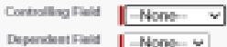
"""""

FdlttdLJ:toliJJiPFiht1,
_......
lJ
Li:i1v.tw!un-ooU,,:,,.1
_..,.,

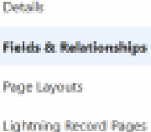


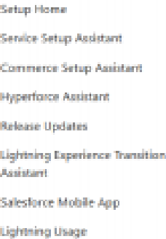
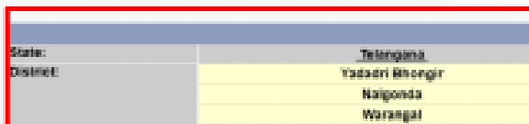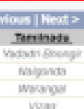
•
Cl,1·i.Ar.rt
Q.�!i.n..p
-�cail:.a1■cal--iai;glll1aWMi'f'blw�n.d.._..._.,lntw,mlSW'I�
-nmavinap.�nmEI-.c1_..,.tiaue1..,a:::lcl.•...,.,,._..,.�.,....wm,1:1�..�tit11---=:..-111ac::a
,llllll�•dd...14ad■.....d......l:IAILNCA..■cHla:v:M!llll"llllplli:.a.hll �
'UMr.t-.,-nte..,r,a,r,•M:lll'lt"1b.u
ll..Hd
i!-.�lljlW.U.a-���n;ia1N-��
., �f•..-M,W,;;
ap:u•u:w
',....
,....
CbiYI
C_4,B.,H.I.M.I,
,.,.,
')Slma:npk,n�fll

- ClickClosetoclosethepreviewwindow,ClickSave.

Activity4:

CreationoffieldsfortheBuyerobjects:

- SelectDatatypeasaPhone,EnteraFieldLabel(Contact),Save.
- SelectDatatypeasanEmail,EnterFieldLabel(Email),Nextsave.
- SelectDatatypeTextarea,EnterFieldLabel(Address),Saveit.
- SelectDatatypePicklist,FieldLabel(BuyerType),Entervalues (Wholesale,Retail),Click Save.

Milestone6-Profile:

Whatisa profile?
Aprofileisagroup/collectionofsettingsandpermissionsthatdefinewhatausercando in

salesforce.Aprofilecontrols“Objectpermissions,Fieldpermissions,Userpermissions,
Tab
settings,Appsettings,Apexclassaccess,Visualforcepageaccess,Pagelayouts,Record Types, Login hours & Login IP ranges.
Aprofilecanbeassignedtomanyusers,butusercanbeassignedsingleprofileatatime.

Activity1:

Createacustomprofile:
- Fromsetup,enterprofilesinQuickFindbox
- Selectprofiles(Standarduser).
- Clickclone.
- ForProfile,enterSalesDepartment.

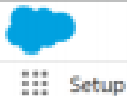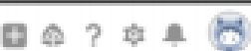
"'.
I11
ProfflK
 | 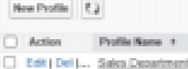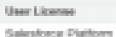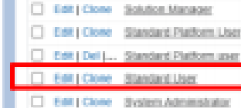Pr,ol'iles |  |  |  |  |  |  |  |  |  |  |  |  |  |  |  |  |  |  |  | Hila-...� | .....
�...1�Pliiwl!DIII■mhawb'  tr,lalr,1Glc:ll:lll�•.-d | Ot•l('leoll�  □t•l�I�  □►-1.::U,lillll..eDilE.I | ..... | --.-........ | A | I | C. | I | , | fl" | I | IP. | I.■ | 'I | O | f, | U | k | 111 | U■• |  | - I� | .-

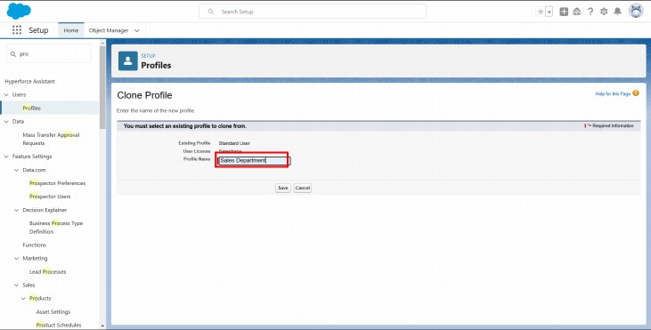

- Clicksave.

Activity2:

Createacustomprofile-2:
Createaprofilewiththeprofilenameas“FarmManager”.

- Fromsetup,enterprofilesinQuickFindbox
- Selectprofiles(Standarduser).
- Clickclone.

Milestone7-Role

In Salesforce, roles are used to determine which users have access to certain data and functionswithinthesystem.Theyarealsousedtodefinethereportinghierarchywithin an organization.Users with higher roles have greater access to data and more control over the system.

Activity-1 Creationofrole

- FromtheQuickfindboxsearchfortheroleandclickontherolesoption
- selectthesetuprolesoption
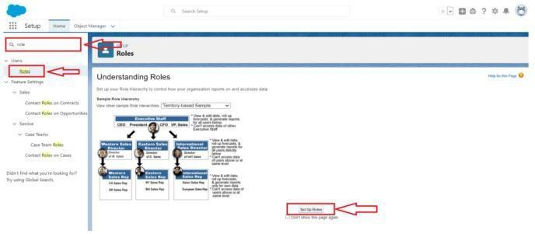

- BelowtheCEOclickonaddroleandenterthelabelnameasa”FarmManager”and role name will be Automatically populated and click on save.
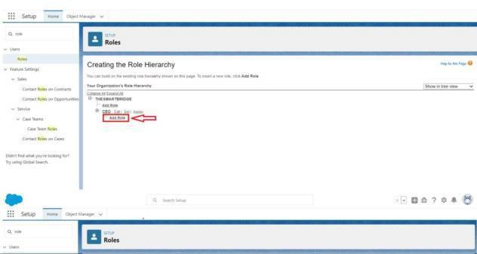

Milestone8-User:

Whatisa user?
AuserisanyonewhologsintoSalesforce.Usersareemployeesatyourcompany,suchas salesreps,managers,andITspecialists,whoneedaccesstothecompany'srecords.Every user in
Salesforcehasauseraccount.Theuseraccountidentifiestheuser,andtheuseraccount settings determine what features and records the user can access.

NOTE-AsSalesforcelicensecanonlybeusedby2UsersatatimeinDevOrg,soIfyou don’t find
salesforcelicensethendeactivateauserwhohassalesforcelicenseOrchangethelicense type from Salesforce to any other.

Activity1:

ToCreateauser:
- FromSetup,enterUsersintheQuickFindbox,thenselectUsers.
- ClickNew User.

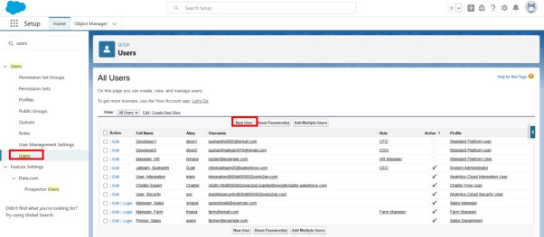

- EnterFirstnameasFarmandlastnameasManager.
- Entertheuser’snameandemailaddressandauniqueusernameintheformofanemail address. By default, the username is the same as the email address.
- SelecttheroleFarmManager.
- SelectuserLicenseasStandardPlatformUser.
- Selectprofile(FarmManager).
- Clicksave.

Activity2:
Createauserwithausernameas“SalesDepartment”,andassignhimthesalesManager profile. Follow the steps from above Activity

Milestone9-SharingRules:

WhatareSharingRules?
Sharing rules help users to share records based on conditions. It is basically created for objectswhoseorganization-widedefaults(OWD)aresettopublicread-onlyorprivate because sharing rules can only extend the access and not restrict it.
Typesofsharingrules,
- Owner-basedSharingRules•Criteria-basedSharingRules

Activity1:

Createasharingrule
- GotoSharingSettings,whichcanbefoundundertheQuickFindsection.
- Scrolldownandfindthecandidateobjectwhereasharingruleneedstobeadded,and then click on New to create a new sharing rule.
- Addthelabelofthesharingruleyouwanttomake.
- Selectyourruletypebasedonthecriteria.
- SelectthefieldcanjoinimmediatelycheckfieldfromtheCropobject.
- SelecttheCropasequalandvalueisTrue.
- AndinselectingtheuserstosharewiththesectionselectrolesandinthatselectFarm Manager.
- Andinthesectionofselectthelevelofaccessfortheusersgivetheaccess Read/Write.
- Andsavetherule.

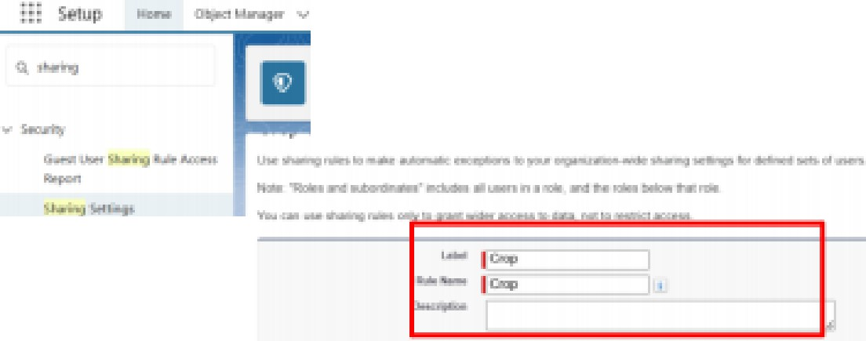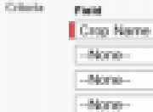
-·-.........
•
Sharir>gSetting•
.....j�...........i..-.-..,.,....
"f"t...-q��
!MN!�1811.,t'l!!Ir•.'-I-M
.---
.., f.b..».-
..litA..
..-
.,..
·�
...
-....
.......
-
_,,
�J:lliP"'

Activity2:

CreateaSharingRuletoSharetherecordsofBuyertoSalesdepartmentwiththeAccess of Read/Write.
FollowthestepsfromaboveActivity.

Milestone-10: User Adoption Activity1:CreateaRecord(Farmer)
  - ClickonAppLauncheronleftsideofscreen.
  - SearchFarmManagement&clickonit.
  - ClickonFarmer Tab.
  - Clicknewandfilldetails&Save.
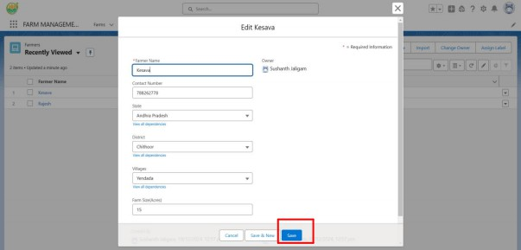

Milestone 11-Reports:

WhatareReports?
A report is a list of records that meet the criteria you define. It's displayed in rows and columns, and can be filtered, grouped, or displayed in a graphical chart. Every report is storedinafolder.Folderscanbepublic,hidden,orshared,andcanbesettoread-onlyor read/write.

Activity1:
Createareport:
Createareportthatdisplaysratingoftheaccountandwhichhastypeandaccountname.
- Clickonapplaunchersearchforreports.
- ClickonthenewreportandselectthecategoryhasFarmerwithFarms.
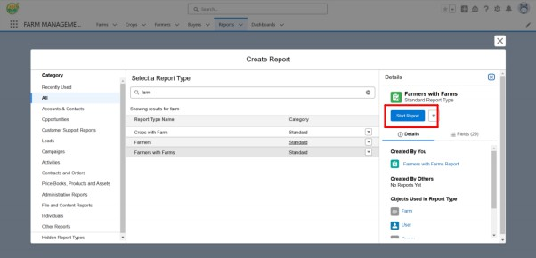

- Inthedetailssectionselecttheoptionstartreport.
- InOutlineClickonColumnSelectWhichFieldyouwanttodisplayintheReport.
- ClickGroup,SelectWhichFieldsYouWanttoGroup.
- Savethereportbygivinglabelname(FarmerwithFarms)andsavethefolderasa public folder and save the report.

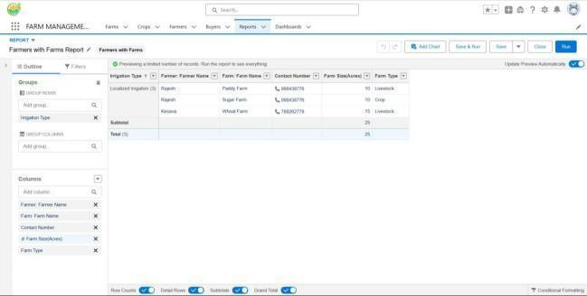

Activity2:
CreateaReportusingtheObjectsCrops,Buyers.FollowthestepsfromaboveActivity.

Milestone12-Dashboard:

Dashboards provide more insights than reports as they combine the data from many reports andshow a summarized result. Looking at many reports at a time gives the flexibility of combining the results from them quickly. Also summaries in dashboards help us decide on action plans quicker. Thedashboardscancontaincharts,graphsand Tabular data.

Activity1:
CreateaDashboard:
- ClicktheDashboardtab.
- ClickNewDashboard.
- NamethedashboardFarmerswithfarmsandclickCreate.
- Click+Component.
- SelecttheFarmerswithFarmsandclickSelect.
- SelecttheGaugechartandclick Add.
- ClickSaveandthenDone.
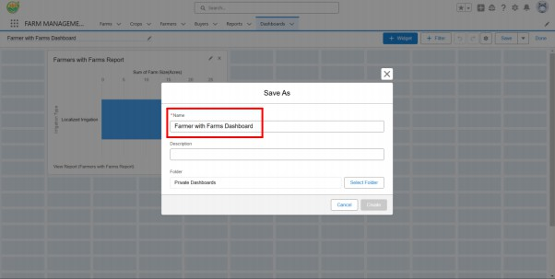

Milestone-13:ViewReportandDashboard: Activity 1: Report
  - ClickonAppLauncheronleftsideofscreen.
  - SearchFarmManagementSystem&clickonit.
  - ClickonReports Tab.
  - ClickonFarmerswithFarms&seerecords
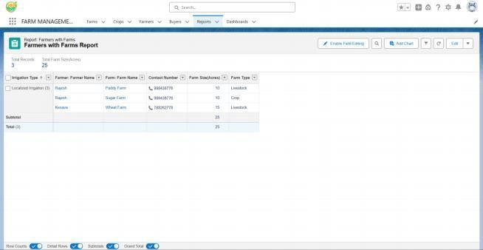

Activity2:Dashboard

- ClickonAppLauncheronleftsideofscreen.
- SearchFarmManagementsystem&clickonit.
- ClickonDashboardTab.
- ClickFarmersWithfarms&seerecords.

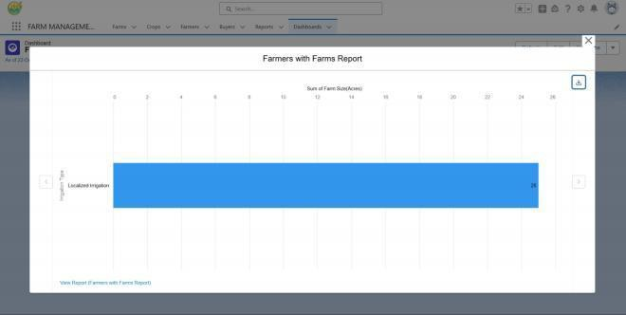

FUNCTIONAL&PERFORMANCETESTING

Duringthetestingphase,screenshotswerecapturedfromtheSalesforceinterfacetoverify system functionality. The following were tested:

  - CreationofFarm,Crop,Farmer,andBuyerrecords
  - Validationofinputfields
  - Relationshipanddependencychecks
  - Profileandroleaccesstesting
  - Sharingruleverification
  - Reportanddashboardgeneration

Performancetestingensuredsmoothsystemresponseandstabilityduringmultipleuser operations.

ADVANTAGES& DISADVANTAGES

Advantages

  - Centralizeddatasystem
  - Reducedpaperwork
  - Improvedaccuracy
  - Bettermonitoring
  - Real-timeanalytics

Disadvantages

  - Requiresinternetconnection
  - Salesforcelicensedependency
  - Limitedofflineaccess

Conclusion:

The Farm Management System successfully digitizes agricultural data management using Salesforce. It improves efficiency, reduces errors, and enables farmers and managers to make informed decisions through automation and analytics.

FUTURESCOPE
  - Mobileapplicationintegration
  - AI-basedcropprediction
  - Weatherdataintegration
  - IoTsensorconnectivity
  - Governmentschemeintegration
  - Marketpriceforecasting

APPENDIX
  - SourceCode:SalesforceConfigurationandMetadata
  - Dataset:Farm,Crop,Farmer,andBuyerRecords
  - ToolsUsed:SalesforceDeveloperOrg

Thank You

